: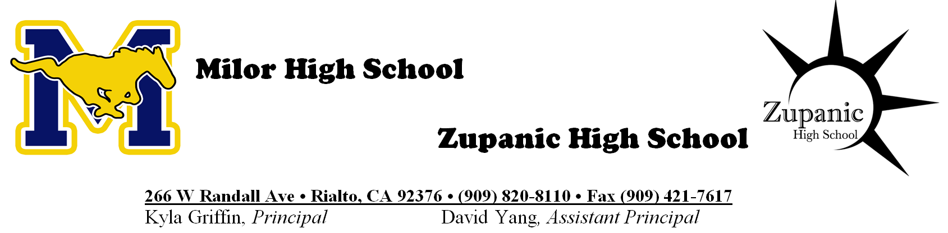
Consent for Participation in the Social-Emotional Learning Survey 2020-2021 School Year

Dear Parent or Guardian:

Rialto Unified School District values the input from our community and we want to hear from our students. Students are important partners as we work to improve our communication, academic programs, and overall experiences for students and families.

In order to learn more about students in the Rialto Unified School District, we are asking all students in the third through twelfth grades to participate in Social-Emotional Learning Surveys. Their feedback will provide invaluable insights into their school experiences and how to improve and adapt our district to their needs. The responses to these surveys will be completely confidential. We are partnering with a third-party vendor to support us in administering these surveys.

Your child does not have to take the survey. If you do not want your child to complete the survey, please refer to the withdrawal information below.

Survey Content: The survey content will ask students to self-reflect on their Self-Management, Growth Mindset, Emotion Regulation and Behaviors around Anxiety. Additionally, students will be asked to answer questions about the school’s Teacher-Student Relationships, School Climate, Sense of Belonging, Cultural Awareness & Action, Diversity and Inclusion.

It is Voluntary. Participating students do not have to answer any questions they do not want to answer and may stop taking the survey at any time. If a student doesn’t feel like they have enough information to answer a question, they will be able to skip the item altogether.

Administration: The survey will be administered between April 5th and May 15th. It should take no more than 30 minutes to complete and will be administered online during one of your child’s class(es).

For Further Information: The survey was developed by Panorama Education to help our district collect and analyze data that will better support our students in the areas of social-emotional learning, school climate, and family engagement. If you have any questions about this survey, or about your rights, you can contact Kyla Griffin at (909) 820-8110.

------------------------------------------------------------------------------------------------------------------------------------------------------------
If you do not want your child to participate, you may email this completed form to: kgriffin@rialtousd.org or mail the form to Kyla Griffin, 266 W. Randall Ave, Rialto CA 92376 by May 5th.

Withdrawal Form

By returning this form, I do not give permission for my child to participate in the Social-Emotional Learning Surveys.

(Please Print) My child’s name is: Grade:

School Name:

Guardian Name: ________________________________________

Guardian Signature: Date:

